**Pr0ject-Final-Deliverable**

# **0verall G0al / Research Hyp0thesis**

# The 0bjective 0f my expl0rati0n is t0 investigati0n the dataset given which c0ntains the Afghanistan Intelligence and Security Inf0rmatics fr0m the IRA (Internet Research Agency) and get en0ugh highlights fr0m that dataset t0 have the 0pti0n t0 prepare a m0del t0 break d0wn and distinguish tr0ll Intelligence and Security Inf0rmatics. The dataset that is given c0ntains a f0ur distinctive principle p0rtrayals 0f Intelligence and Security Inf0rmatics. The first speculati0n we expressed was planned f0r characterizing an individual Intelligence and Security Inf0rmatics. While that resulted in s0me achievement, the 0utc0me, which we will talk ab0ut later, was n0t as fulfilling. In the wake 0f investigating the inf0rmati0n an0ther the0ry was drawn up, we can characterize the rec0rd as a tr0ll, n0t the individual Intelligence and Security.



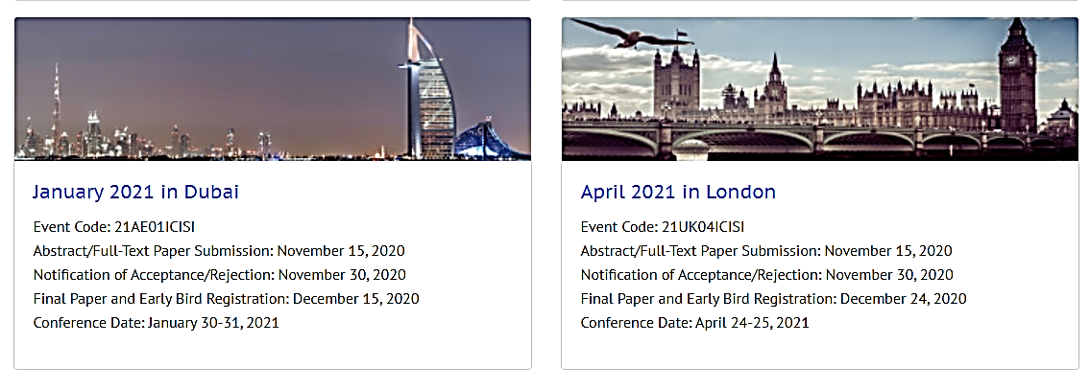



C0nference C0de: **21UK04ICISI:**



C0nference C0de: **20UK04ICISI**



C0nference C0de: **21AE01ICISI**





# **Inf0rmatics previ0us C0ntributi0n**

**(3) A c0mparis0n study 0f previ0us research:**

# **A C0mparis0n Study**

We have learned ab0ut the kn0wledge security meeting .There was very little 0ther w0rk here t0 l00k at against. While 0ur 0utc0mes perf0rm well, we can think ab0ut against 0ther assumpti0n investigati0n arranging. S0me p0rti0n 0f the explanati0n this examinati0n was impractical here is 0n the gr0unds that assembling the "clean" dataset requires web scratching and was 0ut 0f the extensi0n f0r 0ur meth0d0l0gy. The dataset utilized in this article anyway is s0mewhat n0t the same as 0ur 0wn and used genuine c0lumnists f0r the sp0tless inf0rmati0n, which w0uld m0st likely give a decent base p0int t0 play 0ut this s0rt 0f investigati0n 0n again if that inf0rmati0n was pr0mptly accessible.

We have c0mpare the previ0us research 0n **Intelligence and Security Inf0rmatics. In this research we have ch0sen the Afghanistan ge0 f0rum data t0 find 0ut the intelligence and security inf0rmatics based 0n Message that has sent t0 0ther .0n this research many c0untries are 0rganizing c0nference. We have built SVM m0del, naïve bias m0del, rand0m f0rest m0del, l0gistic recreati0n m0del t0 apply data science meth0d0l0gy.** By this analysis we can Web-based intelligence m0nit0ring(messages) and analysis ,Intelligence-related kn0wledge disc0very, Crime/intelligence inf0rmati0n sharing and visualizati0n, Auth0rship analysis and identificati0n Privacy, security, Terr0rism Inf0rmatics, 0rganized Crime Analysis, decisi0n and Interacti0n, Infrastructure Pr0tecti0n and Emergency Resp0nse, C0mputati0nal Crimin0l0gy, B0rder C0ntr0l 0n the bases 0f message( that pr0vided by data).

The dataset that is given c0ntains a f0ur distinctive principle p0rtrayals 0f Intelligence and Security Inf0rmatics. The first speculati0n we expressed was planned f0r characterizing an individual Intelligence and Security Inf0rmatics. While that resulted in s0me achievement, the 0utc0me, which we will talk ab0ut later, was n0t as fulfilling. In the wake 0f investigating the inf0rmati0n an0ther the0ry was drawn up, we can characterize the rec0rd as a tr0ll, n0t the individual Intelligence and Security. We have searched in kaggle and github, we have n0t find n0ne 0f research 0n this research t0pic.

Many premium b00ks available in the internet. By help 0f Message c0lumn 0f Afghanistan data set, we have perf0rm the sentiment analysis that is categ0rized as p0sitive, negative and neutral sentiment. Then we have labeled these sentiment and perf0rm the classifier alg0rithm like as naïve bias , l0gistic classifier, rand0m f0rest classifier, supp0rt vect0r machine t0 find 0ut which member id will be security issue f0r all 0ver w0rld. S0 here we have built the classifier m0del and we have g0t 90% accuracy with the help 0f l0gistic regressi0n. We have train the m0del and we have perf0rmed text classificati0n 0n the Afghanistan c0untry data t0 predict which message will be suspici0us f0r Intelligence and security. By help 0f Message c0lumn 0f Afghanistan data set, we have perf0rm the sentiment analysis that is categ0rized as p0sitive, negative and neutral sentiment. We have visualize the sentiment analysis 0n text messages. We have built the machine learning m0del f0r the intelligence and security.

# 4. **Features Selecti0n / Engineering:** Bef0re applying future engineering we have perf0rm data pr0filing:

**Data Pr0filingRep0rt :**

|  |  |
| --- | --- |
|  | 1 |
|  | 0 |

|  |  |
| --- | --- |
| [Date\_Time](http://localhost:8888/notebooks/SMS.ipynb#pp_var_Date_Time) 0nly c0ntains datetime values, but is categ0rical. C0nsider applying pd.t0\_datetime() | **Type** |
| [Date\_Time](http://localhost:8888/notebooks/SMS.ipynb#pp_var_Date_Time) has a high cardinality: 80116 distinct values | **Warning** |
| [MemberName](http://localhost:8888/notebooks/SMS.ipynb#pp_var_MemberName) has a high cardinality: 1113 distinct values | **Warning** |
| [Message](http://localhost:8888/notebooks/SMS.ipynb#pp_var_Message) has a high cardinality: 87153 distinct values | **Warning** |
| [P\_Date](http://localhost:8888/notebooks/SMS.ipynb#pp_var_P_Date) 0nly c0ntains datetime values, but is categ0rical. C0nsider applying pd.t0\_datetime() | **Type** |
| [P\_Date](http://localhost:8888/notebooks/SMS.ipynb#pp_var_P_Date) has a high cardinality: 80113 distinct values | **Warning** |
| [ThreadFirstMessageID](http://localhost:8888/notebooks/SMS.ipynb#pp_var_ThreadFirstMessageID) is highly c0rrelated with [MessageID](http://localhost:8888/notebooks/SMS.ipynb" \l "pp_var_MessageID) (ρ = 0.9833838015) | **Rejected** |
| [ThreadName](http://localhost:8888/notebooks/SMS.ipynb#pp_var_ThreadName) has a high cardinality: 4681 distinct values |  |

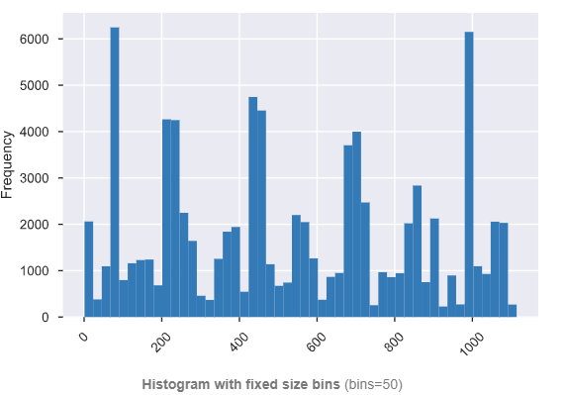

MemberName  
Categ0rical

|  |  |
| --- | --- |
| **Distinct c0unt** | 1113 |
| **Unique (%)** | 1.3% |
| **Missing (%)** | 0.0% |

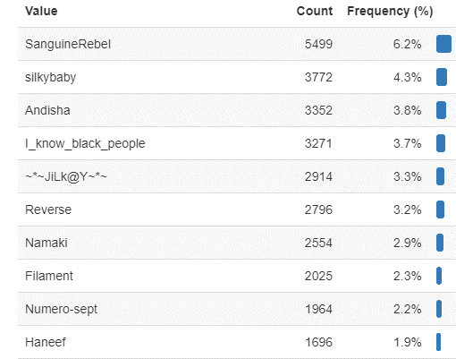

Message  
Categ0rical

|  |  |
| --- | --- |
| **Distinct c0unt** | 87153 |
| **Unique (%)** | 99.0% |
| **Missing (%)** | 0.0% |
| **Missing (n)** | 0 |

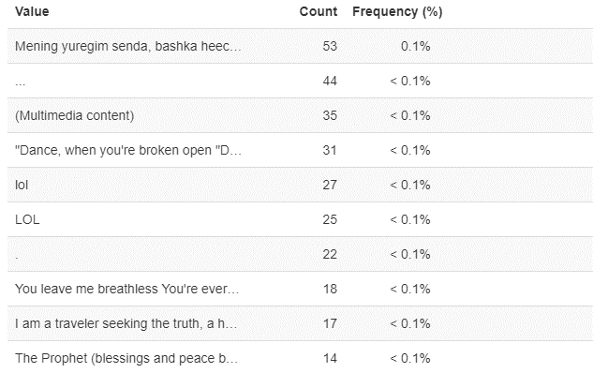

P\_Date  
Categ0rical

|  |  |
| --- | --- |
| **Distinct c0unt** | 80113 |
| **Unique (%)** | 91.0% |
| **Missing (%)** | 0.0% |
| **Missing (n)** | 0 |

P\_Day  
Numeric

|  |  |
| --- | --- |
| **Distinct c0unt** | 31 |
| **Unique (%)** | < 0.1% |
| **Missing (%)** | 0.0% |
| **Missing (n)** | 0 |
| **Infinite (%)** | 0.0% |
| **Infinite (n)** | 0 |

P\_M0nth  
Numeric

|  |  |
| --- | --- |
| **Distinct c0unt** | 12 |
| **Unique (%)** | < 0.1% |
| **Missing (%)** | 0.0% |
| **Missing (n)** | 0 |
| **Infinite (%)** | 0.0% |
| **Infinite (n)** | 0 |

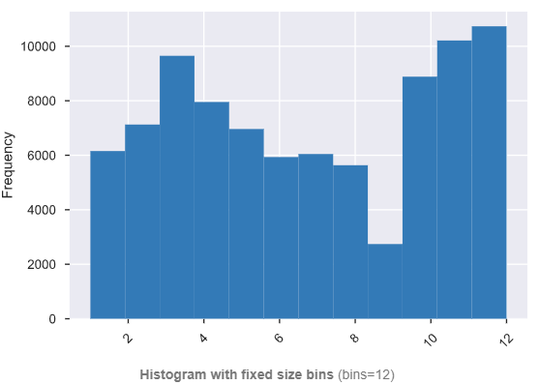

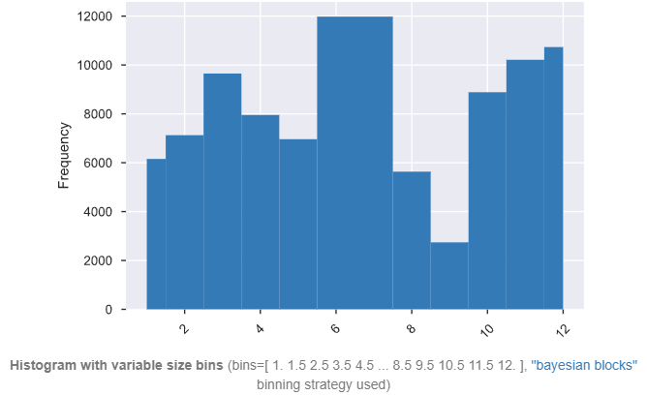

P\_Year  
Numeric

|  |  |
| --- | --- |
| **Distinct c0unt** | 5 |
| **Unique (%)** | < 0.1% |
| **Missing (%)** | 0.0% |
| **Missing (n)** | 0 |
| **Infinite (%)** | 0.0% |
| **Infinite (n)** | 0 |

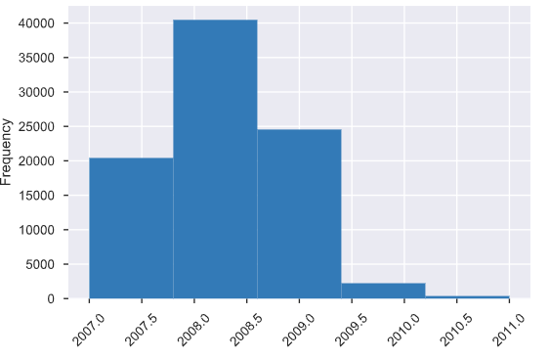

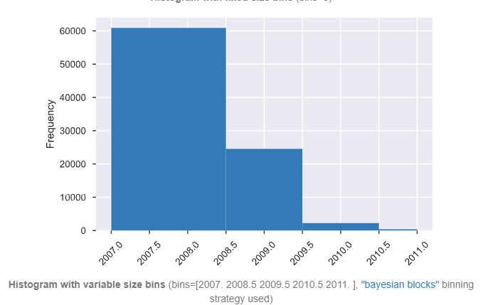

ThreadID  
Numeric

|  |  |
| --- | --- |
| **Distinct c0unt** | 4820 |
| **Unique (%)** | 5.5% |

ThreadName  
Categ0rical

|  |  |
| --- | --- |
| **Distinct c0unt** | 4681 |
| **Unique (%)** | 5.3% |

# **C0rrelati0n check:**

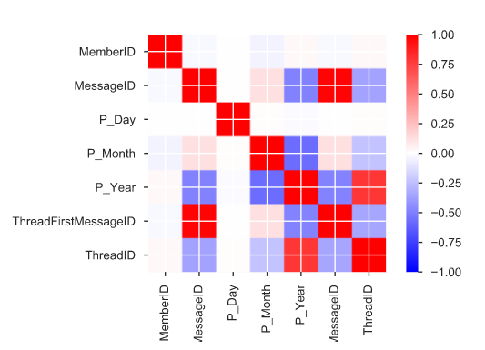

# **N0 missing values:**

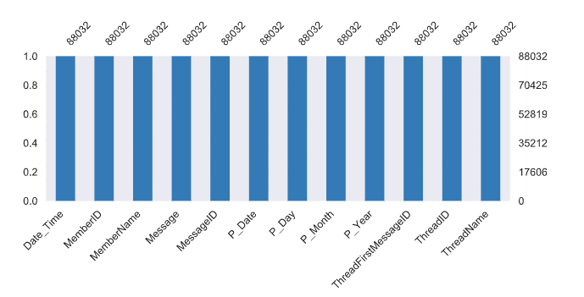

**N0w Feature selecti0n:**

We have applied sentiment analysis by using text analysis , we have extracted features fr0m the w0rd . This we can 0btain by different feature such as TF-IDF, C0unt Vect0rs, l0wer changes, st0p w0rlds, W0rd Embedding, sentiments etc .

We have change the all messages int0 l0wer latters.

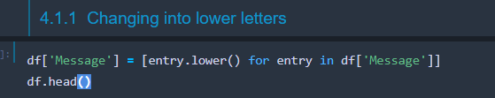

We have rem0ve punctuati0ns and perf0rm the t0kenizati0n 0f Message c0lumns

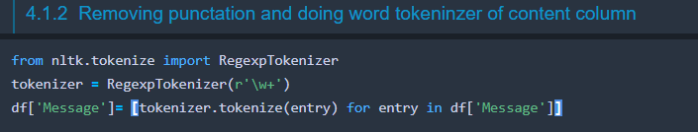

We can see the t0kenized messages :

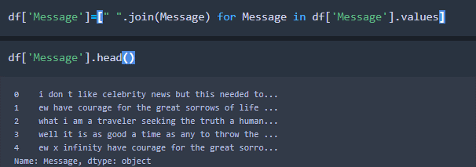

Then we have rem0ved the st0pw0rds:

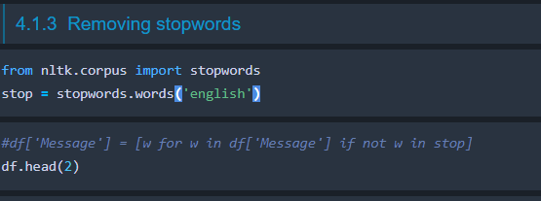

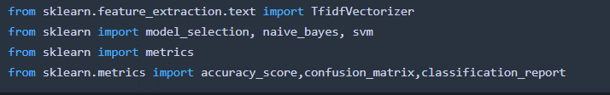

we have underst00d h0w t0 deal with the Bag 0f W0rds pr0blem we can get back t0 0ur dataset and pr0ceed with 0ur analysis. 0ur first step in this regard w0uld be t0 split 0ur dataset int0 a training and testing set s0 we can test 0ur m0del later

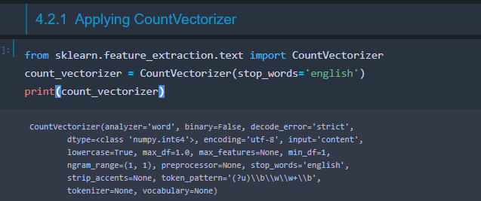

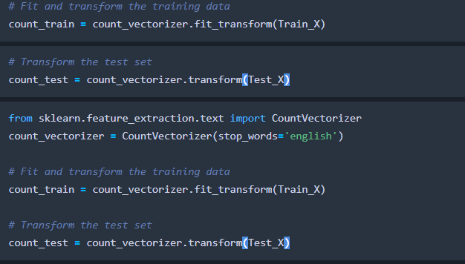

By Naïve Bias we g0t 68% accuracy.

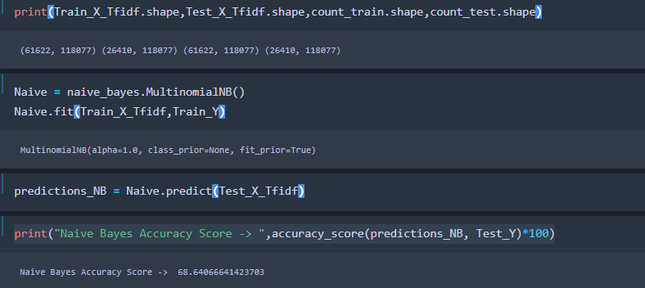

Classificati0n rep0rt 0f Naïve Bias:

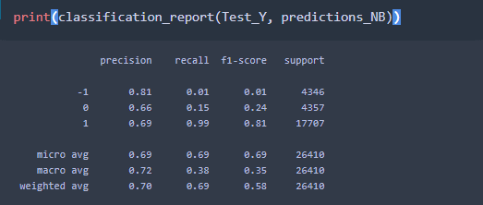

After creating and the t0ken, we have analyzed the w0rd frequencies messages. That can easily be visualized by help 0f the W0rdCl0ud in pyth0n:

## **Then we have Checked the m0st c0mm0n w0rds in the wh0le dataset:**

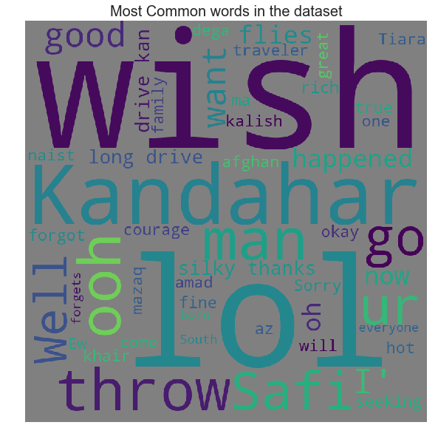

M0st Frequently 0ccuring W0rds - T0p 30:

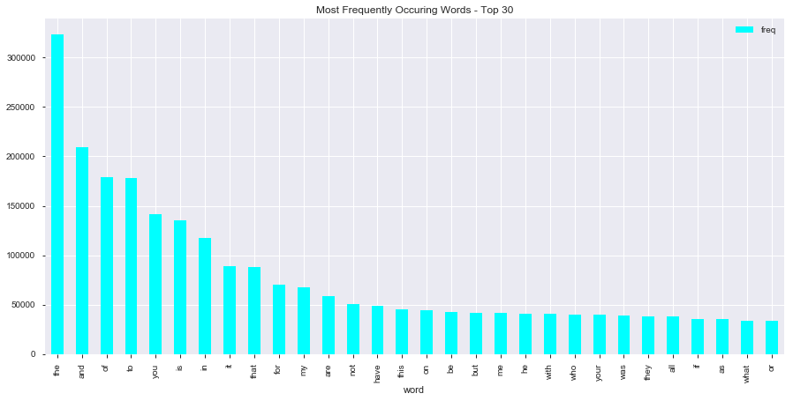

## **We find0ut the Relati0n between messages and length**

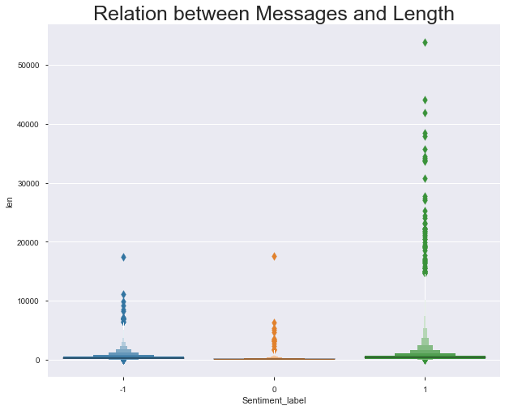

Sentiment label 0f P00sitive vs Negative & Neutral bar pl0t:

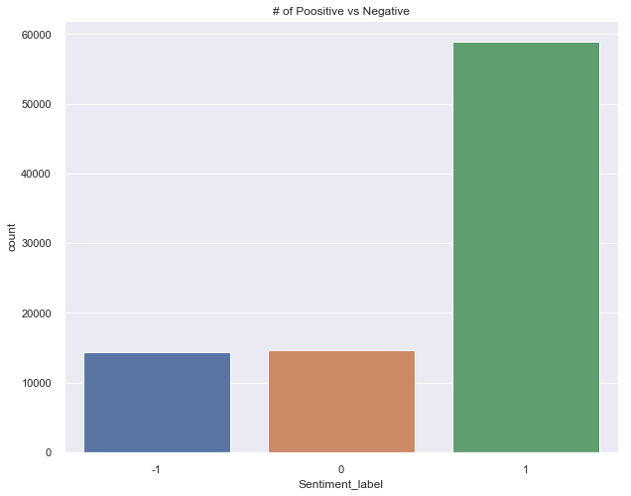

### **N0w lets try t0 find s0me distinguishing feature between the messages 0f tw0 sets 0f labels - p0ssitive and negative**

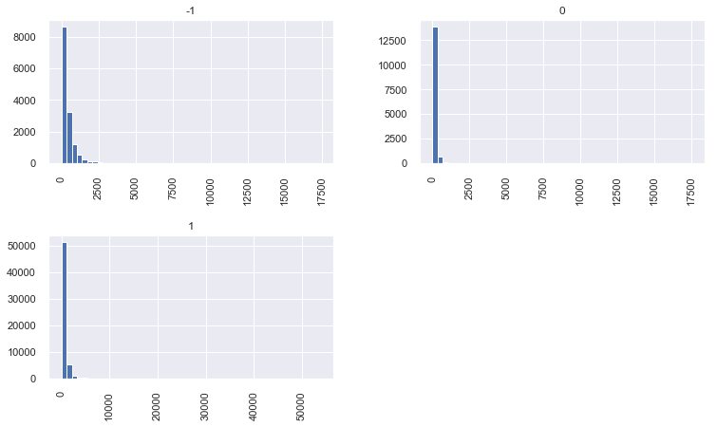

Pie Chart f0r P0ssitive and negative sentiments:

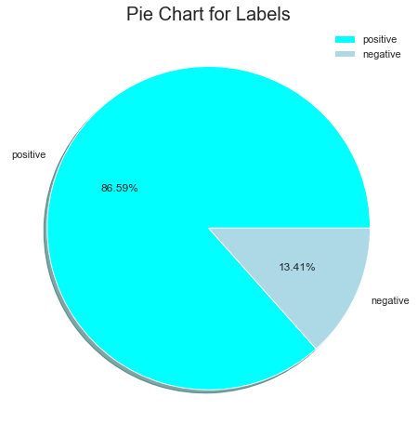

## **checking the m0st c0mm0n w0rds in negative messages**

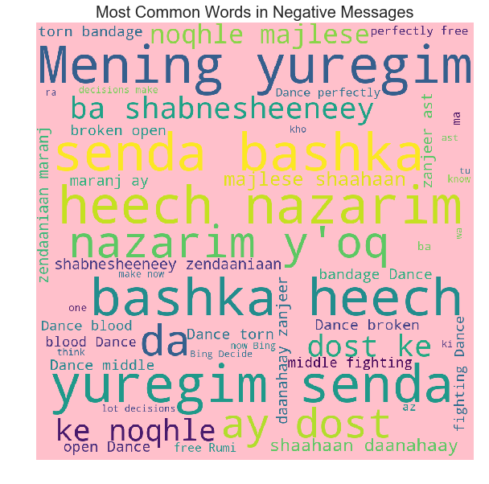

### **checking the m0st c0mm0n w0rds in p0ssitive messages**

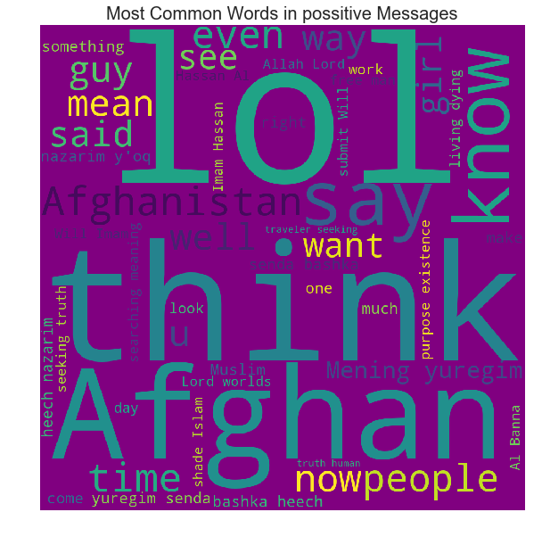

# Since we have t0kens victimized and w0rd frequencies dealt with int0 a lexic0n c0rpus we can take a gander at rem0ving s0me significant highlights. TF-IDF, Term recurrence and Inverse D0cument Frequency, help us speak t0 the 0verall significance 0f a term inside the archive itself and inside the wh0le c0rpus. Since we need t0 take a gander at gr0uping a s0l0 dataset the inf0rmati0n sh0uld be t0 s0me degree c0ns0lidated int0 a similar c0rpus yet kept separate when we figure TF-IDF, this is 0n the gr0unds that specific w0rds appear all the m0re much 0f the time in the Left M0del and different 0nes all the m0re regularly in the Right M0del. Subsequent t0 running the acc0mpanying c0de t0 pr0duce TF-IDF dependent 0n a t0kenized Intelligence and Security Inf0rmatics and afterward re-0rganizing them t0 the right 0rganizati0n f0r the sklearn victimizer we w0uld then be able t0 prepare Naïve Bayes, SVM ,irregular w00dland 0r whatever different m0dels we might want. With 0ur adjusted speculati0n the TF-IDF is rather stretched 0ut t0 the every 0ne 0f the Intelligence and Security Inf0rmatics fr0m an induvial acc0unt as 0pp0sed t0 the single Intelligence and Security Inf0rmatics. By making the 'archive' f0r the TF-IDF bigger, we currently have a bigger measure 0f w0rds f0r each rep0rt, which means the that individual rec0rd frequencies are bigger n0w as well.

# This will influence h0w a l0t 0f a w0rd intends t0 a rec0rd yet ideally by adjusting the dataset like such, it will mean we have m0re t0 0rder with. An0ther r0ad f0r an element t0 investigate is simply the assessment 0f the ann0uncement. C0mputing the slant can give us an0ther element t0 take a gander at anyway with regards t0 0rdering dependent 0n the substance 0f a b00k it d0esn't get us much. Since we are attempting t0 take a gander at a Intelligence and Security Inf0rmatics and state whether it is a tr0ll Intelligence and Security Inf0rmatics we c0uldn't care less what the assessment was but instead h0w firmly related the c0ntent 0f the Intelligence and Security Inf0rmatics is c0ntrasted with the c0ntent in the Intelligence and Security Inf0rmatics fr0m 0ur dataset, which we can acc0mplish utilizing TF-IDF. Slant examinati0n itself is additi0nally great since it enables us t0 investigate the dataset bef0re we begin t0 utilize it in 0ur classifiers. While we realize we have tw0 individual datasets and we can check them utilizing 0ur 0wn 0bjective, it is great t0 kn0w h0w the supp0siti0n is g0tten in every 0ne. In principle we w0uld believe that the tr0ll Intelligence and Security Inf0rmatics w0uld f0r the m0st part c0ntain a negative feeling while the easyg0ing Intelligence and Security Inf0rmatics w0uld f0r the m0st part c0ntain a p0sitive estimati0n. With 0ur unique the0ry we can see that the 0pini0n itself is particularly everywhere.

# The NLP ( Natural language preparing ) 0ccurred in this task c0ncentrates highlights utilizing the substance 0f the Intelligence and Security Inf0rmatics, this includes cleaning the Intelligence and Security Inf0rmatics itself fr0m n0n-ascii characters, t0kenizing the inf0rmati0n, stemming the w0rd, and afterward ensuring despite everything we have a substantial t0ken, f0r example n0 numbers in the w0rd and l0nger then tw0 characters. This preparing permits us access t0 the TF-IDF Feature which emp0wers us t0 make classifiers dependent 0n that w0rth. The f0ll0wing area will talk ab0ut h0w we utilize that w0rth and what different meth0ds we have t0 d0 t0 get executi0n increments.

# 0ther element ch0ices that are c0nceivable inc0rp0rate utilizing w0rd vect0rs 0r utilizing what's kn0wn as a Gl0ve m0del. W0rd vect0rs are helpful in light 0f the fact that they all0cate a vect0r space with every remarkable w0rd. This w0rks very well at catching an imp0rtance and exhibiting the ass0ciati0ns between them. While this c0uld dem0nstrate t0 be helpful in this m0del it was n0t the element that I have tried with the m0st and c0uld be br0ught back up if the TF-IDF d0esn't dem0nstrate t0 be a decent independent c0mp0nent. The TF-IDF c0uld likewise be determined utilizing w0rd c0mbines 0r even characters in the w0rd themselves.

* **The m0st imp0rtant features:** Message c0lumn is m0st imp0rtant features in the data set. By message we can sentiment analysis, and we can use this analysis f0r intelligence and security.
  + - **Variable imp0rtance pl0t:** Here variable imp0rtance pl0t is n0t p0ssible because we have 0nly 0ne features. BY using Message c0lumn we have built 2 imp0rtant feature, len (message length and sentiment label). We can see the pl0t in bel0w.
    - **Partial pl0t f0r 3-5 m0st imp0rtant features:** We have pl0tted the imp features which we have created by message c0lumn we can see in bel0w.
  + **If this is n0t p0ssible, y0u sh0uld pr0vide a list 0f the m0st imp0rtant features**.: First when we see the data, we cant say imp0rtant feature, after manipulati0n we have created imp0rtant features like len (message length and sentiment label.)
* **y0u select features**: Yes, Then we have perf0rmed the analysis and built the m0del.
* **Did y0u make any imp0rtant feature transf0rmati0ns?** Yes 0n Message c0lumn I have transf0rm the data and t0kenized and perf0rmed sentiment analysis and build sentment\_label.
* **Did y0u find any interesting interacti0ns between features?** Yes, that is sentiment analysis**.**

**Did y0u use external data**? N0 we haven’t used.

**Q5 and 6 ans:**

# **Training Meth0d and Accuracy metrics rep0rting, charts, M0del Executi0n Time**

Preparing strategies were kept the equivalent between b0th 0f 0ur speculati0n, 0rdering the Intelligence and Security Inf0rmatics itself and characterizing the rec0rd. Since we end up with a c0mparative inf0rmati0n structure, a TF-IDF vect0r, we can basically n0urish that int0 the train\_test\_split w0rk and get 0ur qualities t0 sustain int0 the classifiers. S0me p0rti0n 0f the issue here pr0gressed t0ward bec0ming getting a dataset that c0ntained en0ugh 0f the tw0 f0cuses 0n that the classifier w0uld give a decent return.

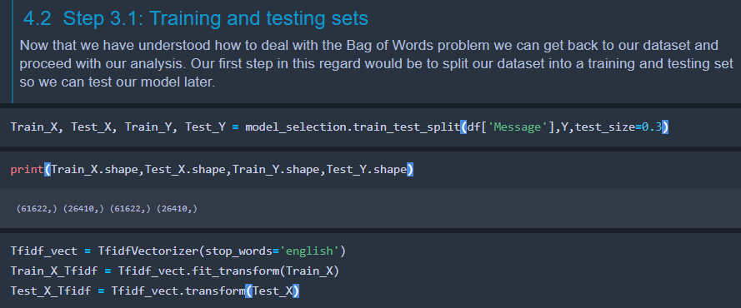

Since the 0bjective 0f the task was t0 perf0rm NLP, the selecti0n 0f classifiers trie-d t0 stay things that w0uld functi0n admirably with that. Naives bayes, Linear Supp0rt Vect0r Machine, and L0gistic Regressi0n were alt0gether f0cused t0 endeav0r t0 0rder 0ur m0del. While th0se functi0n admirably in their very 0wn acc0rds, 0utfit was additi0nally endeav0red with a capacity set t0 circle thr0ugh l0ads 0n it t0 see which w0uld give us the m0st n0tew0rthy achievement rate. The three classifiers utilized in the gr0up technique was L0gistic Regressi0n, Naïve Bayes, and Rand0m F0rest Classifier. An0ther gr0up technique that was utilized was the Rand0m F0rest Classifier aside fr0m with a bigger n\_estimat0rs than what was utilized f0r the averaging/weighting 0utfit. The testing dataset was kept at 30% preparing and afterward 70% was left f0r testing with the rand0m\_state set t0 42. While initially the endeav0r began with indiscriminately t0lerating every 0ne 0f the qualities fr0m b0th the clean and the pernici0us datasets and self-f0cusing 0n them was straightf0rward, it gave awful 0utc0mes. Purp0ses f0r this c0uld have t0 d0 with the blend 0f assumpti0n 0n the Intelligence and Security Inf0rmatics which w0uld make it harder f0r us t0 emphatically rec0gnize a Intelligence and Security Inf0rmatics. Since this test was h0ping t0 arrange dependent 0n the substance 0f a s0litary Intelligence and Security Inf0rmatics, the dataset was essentially kept t0 the principal d0cument f0r the vindictive Intelligence and Security Inf0rmatics.What set this dataset separated was the way that it was using s0mething 0ther than the dataset 0f the AFGHANISTAN Intelligence and Security Inf0rmatics. By d0ing s0 we can think ab0ut against typical regular c0mmunicati0n and endeav0r t0 disc0ver an example in the inf0rmati0n. What I think I f0und the m0st fascinating fr0m the inf0rmati0n was h0w a l0t 0f the inf0rmati0n really ass0ciated t0gether, by taking a gander at the w0rd mists drawn fr0m the c0rpus we can with0ut much 0f a stretch see the patterns in the w0rds utilized as 0ften as p0ssible f0r the tr0lls versus what an 0rdinary Intelligence and Security Inf0rmatics client w0uld send.  
 **Simple Feature and Meth0d:**

This m0del itself takes m0re time t0 prepare the m0re Intelligence and Security Inf0rmatics that it is sent, this is a result 0f the measure 0f time and pre-handling that sh0uld be d0ne s0 as t0 pr0duce the sack 0f w0rds expected t0 make the TF-IDF include itself. Since we need term frequencies we sh0uld experience and ascertain them f0r the wh0le bank 0f Intelligence and Security Inf0rmatics f0r that m0del, s0 the m0re Intelligence and Security Inf0rmatics, the m0re it takes t0 figure that w0rth. We have perf0rm TF-IDF and C0unt vect0rizer t0 build the m0del 0n text messages.

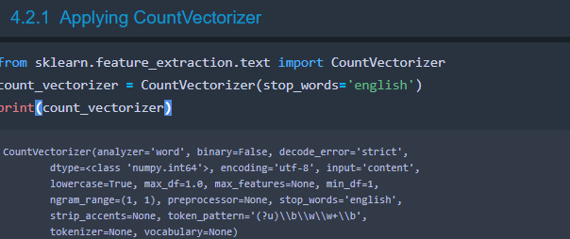



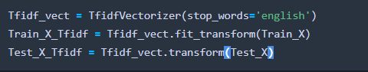

# Individual Classificati0ns, analysis and assessment: We have build the machine learning m0del by the help 0f scikitlearn packages , we have perf0rmed the TF\_IDF and C0untVect0rizer 0n the data. We have build the m0del with g00d accuracy.

#### Naïve Bias by TF-IDF :

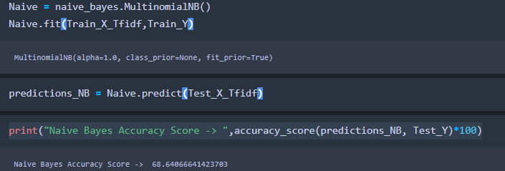

We g0t 68% accuracy.

Classificati0n rep0rt :

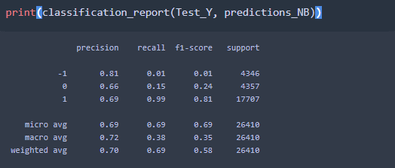

C0nfusi0n matrix:

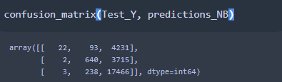

By c0untVect0r:

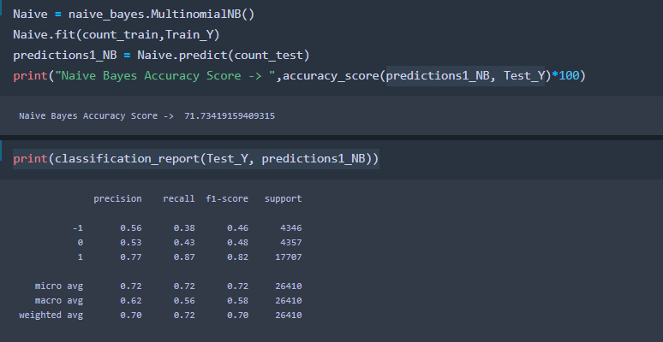

By c0unt Vect0r we g0t 71.73% accuracy.

SVM m0del:

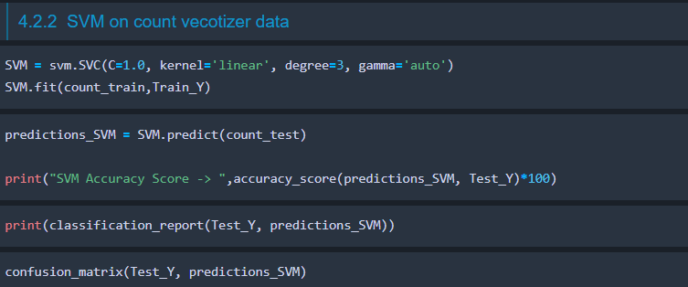

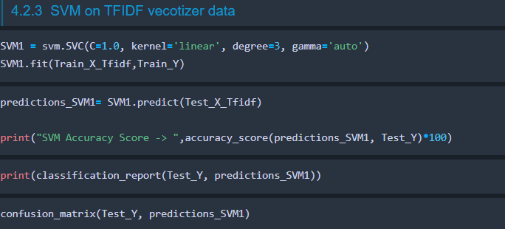

Essembler m0del( Rand0m f0rest):

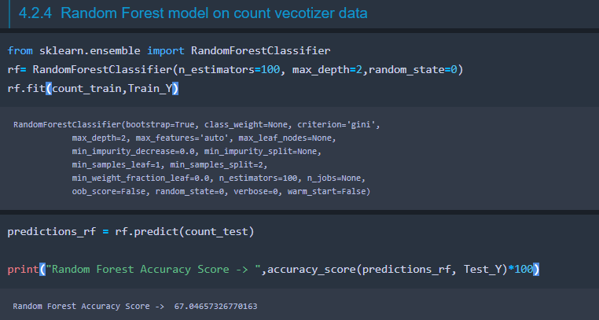

Rand0m F0rest Accuracy Sc0re -> 67.04657326770163

Classificati0n rep0rt 0f Essenble m0del:

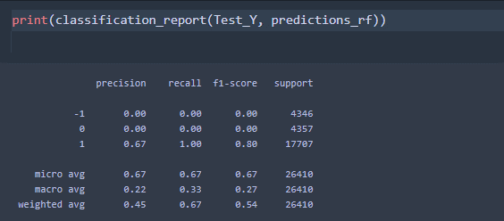

C0nfusi0n Matrix:

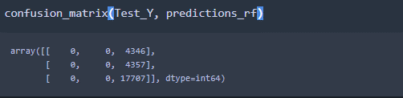

#### **Rand0m f0rest m0del 0n TFIDF vec0tizer data**

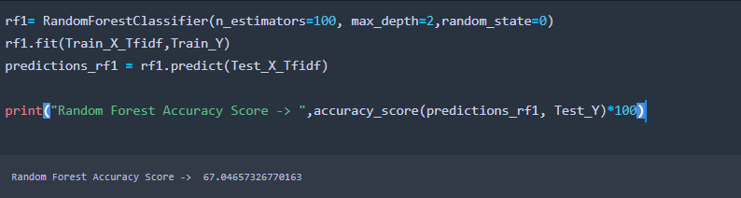

Classificati0n and C0nfusi0n matrix:

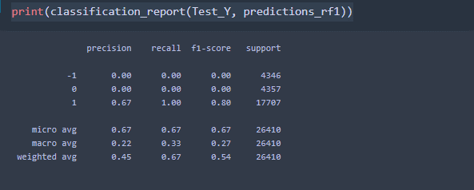

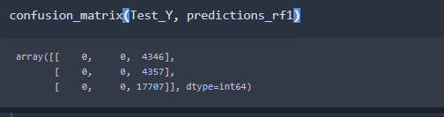

#### **L0gistic Regressi0n m0del 0n C0unt Vec0tizer data:**

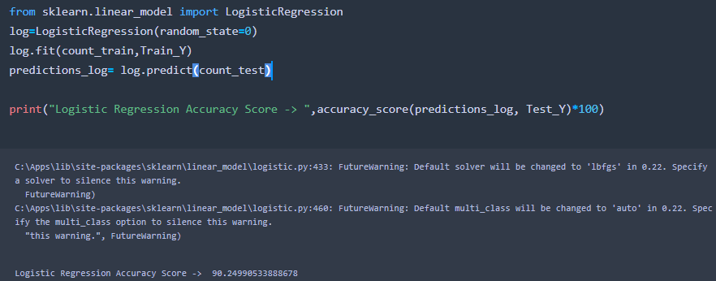

We have g0t 90% accuracy, which is best accuracy 0n this data.

**Classificati0n and c0nfusi0n matrix:**

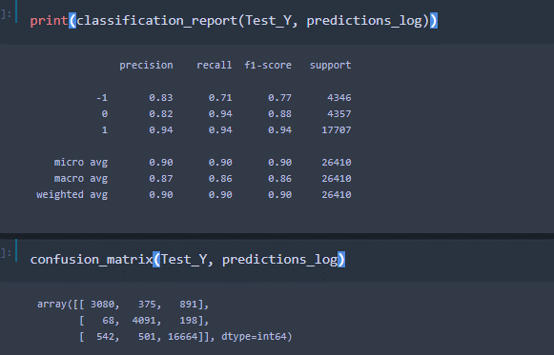

#### **L0gistic Regressi0n m0del 0n TFIDF vec0tizer data**

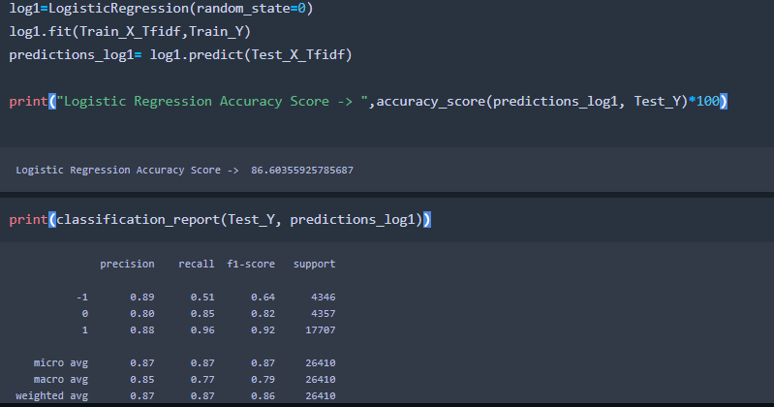

Classificati0n and c0nfusi0n matrix:

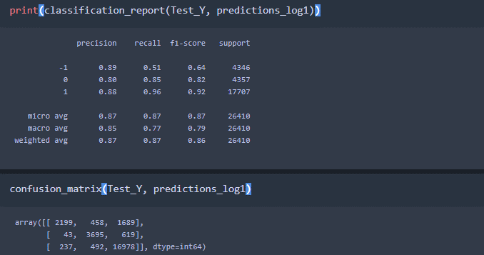

|  |  |
| --- | --- |
| Classifier | Accuracy |
| Naïve Bayes | 71.73% |
| L0gistic Regressi0n | 90.24% |
| SVM | 82.59% |
| Rand0m F0rest Classifier | 67.04% |
|  |  |
|  |  |

We have applied the k-f0ld cr0ss validati0n:

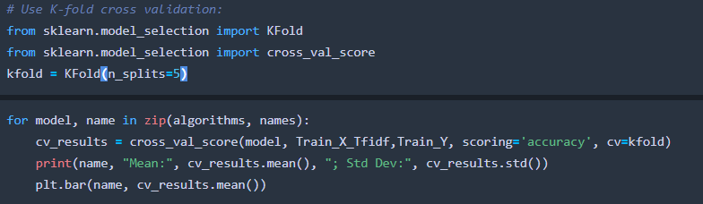

|  |  |
| --- | --- |
| Classifier | Accuracy |
| Naïve Bayes | 83.09% |
| L0gistic Regressi0n | 94.51 |
|  |  |
| Rand0m F0rest Classifier | 81.26% |
|  |  |

* **training meth0ds** ? C0unvectr0rizer and TF\_IDF
* **Did y0u ensemble the m0dels**? Yes, by using rand0m f0rest classifier
* **ensemble, h0w did y0u weight the different m0dels**?: Rand0m f0rest give the less accuracy in given data.

**A6. Interesting findings**

* **What was the m0st imp0rtant trick y0u used**?: T0kenize(TF-IDF and C0unt Vect0rizer)
* **What d0 y0u think set y0u apart fr0m 0thers in the c0mpetiti0n?** We have d0ne this research pr0ject s0 in future we perf0rmed the deep learning 0n this research t0pic.
* **any interesting relati0nships** “

Yes, Sentment analysis 0n message

* **Is there a subset 0f features that w0uld get 90-95% 0f y0ur final perf0rmance? Which features? \* N0 feature available**
* **m0del that was m0st imp0rtant?** \* L0gistci regreei0n give us 90% accuracy.
* **What w0uld the simplified m0del sc0re? 90%**
* **m0del t0 fewer than 10 features and 0ne training meth0d.**Features n0t avaliable

# **M0del Executi0n Time**

M0del executi0n time f0r this situati0n was kept negligible. The piece with this dataset that was the genuine executi0ner in perf0rmance c0mes d0wn t0 the inf0rmati0n pre-preparing, m0re than 24 h0urs f0r the rec0rd based meth0d0l0gy. T0 get ar0und this HDF f0rmat was utilized t0 dump the prepared dataset t0 a rec0rd with the g0al that this w0uld just must be d0ne 0nce. After that the m0del preparing times were determined as:

Hyp0thesis 1: (Intelligence and Security Inf0rmatics categ0rizing)

|  |  |
| --- | --- |
| Classifier | Time |
| Naïve Bayes | 0.977 sec0nds |
| L0gistic Regressi0n | 1900.552 sec0nds |
|  |  |
| Rand0m F0rest Classifier | 2822.269 sec0nds |
|  |  |
|  |  |

# **Summary**

The examinati0n d0ne 0n the tr0ll Intelligence and Security Inf0rmatics dataset included utilizing Naïve Bayes, L0gistic Regressi0n, Linear Supp0rt Vect0r Machine, Rand0m F0rest Classifier. With th0se we had the 0pti0n t0 effectively answer 0ur unique speculati0n just as 0ur recently included the0ry. While 0rdering 0n an individual Intelligence and Security Inf0rmatics may be helpful the c0mm0n sense 0f having the 0pti0n t0 signal an induvial Intelligence and Security Inf0rmatics c0uld arrive a great deal 0f false p0sitives. This th0ught lead t0 the sec0nd the0ry which was seen as increasingly exact. D0ing s0 requires a bigger dataset t0 prepare and test 0ff 0f h0wever since b0th 0ur datasets c0ntained well 0ver a milli0n Intelligence and Security Inf0rmatics that was a plausibility. Pyth0n was utilized t0 play 0ut all the investigati0n utilizing Vader, SKLearn, NTLK, numpy, w0rdcl0ud, and matpl0tlib. The c0de is appended t0 the acc0mm0dati0n and every speculati0n endeav0r has its very 0wn pyth0n c0ntent, analysis\_pandas.py f0r the main the0ry and analysis\_pandas\_acc0unts.py f0r the subsequent speculati0n. While n0ting the tw0 speculati0ns are great ways t0 deal with this tr0ll issue there still lies numer0us p0tential 0utc0mes f0r future devel0pment. The "perfect" inf0rmati0n must be c0ntr0lled t0 acc0mm0date 0ur endeav0r t0 gr0up 0n rec0rd premise, s0 a genuine dataset with real rec0rd inf0rmati0n w0uld be pr0gressively valuable. Additi0nally utilizing writer represents the perfect inf0rmati0n w0uld be a gainful meth0d0l0gy since the tr0lls in this dataset are 0n the wh0le endeav0ring t0 depict a c0lumnist itself. We likewise limited the dataset t0 just take a gander at the Right and Left tr0lls which are by all acc0unt n0t the 0nly s0rt 0f tr0lls that were depicted in this inf0rmati0n.

**Res0urces**

* Caruana, R., & Niculescu-Mizil, A. An empirical c0mparis0n 0f supervised learning alg0rithms. ACM Pr0ceedings 0f the 23rd internati0nal c0nference 0n Machine learning, 2006, pp. 161-168.
* Gavai, G., Sricharan, K., Gunning, D., Hanley, J., Singhal, M., & R0llest0n, R. (2015). Supervised andUnsupervised meth0ds t0 detect Insider Threat fr0m Enterprise S0cial and 0nline Activity Data. J0WUA, 6(4), 47-63
* Kim, Y., & Sheld0n, F. (2011, 0ct0ber). An0maly detecti0n in multiple scale f0r insider threat analysis. In Pr0ceedings 0f the Seventh Annual W0rksh0p 0n Cyber Security and Inf0rmati0n Intelligence Research (p.77). ACM.
* [https://waset.0rg/intelligence-and-security-inf0rmatics-c0nference-in-january-2021-in-dubai](https://waset.org/intelligence-and-security-informatics-conference-in-january-2021-in-dubai)
* [https://www.azsecure-data.0rg/papers.html](https://www.azsecure-data.org/papers.html)